**Visualizations of Colorado State Education System**

Jaideep Patel - [jaipatel@iu.edu](mailto:jaipatel@iu.edu)

YouTube - TBD

GitHub – TBD

**Project Objective:**

Colorado School Grades data set was created by a coalition of non-profit, community organizations that believe all children deserve access to a high-performing school. The mission is to provide community members, parents, students, and educators with school performance information that is both accessible and easy-to-understand. Information is power and we shall strive to direct our work towards unwinding the hidden trends in the data and provide meaningful insights to the community. The tasks included in this project will result in students and parents being able to make better decisions in terms of selecting a school. Also, it would help the educators to analyze the performance of their schools and compare them with other highly reputed schools in the state. As a result, educators will have the tools necessary to improve the education standards and provide the students at more schools with a higher quality of education. A rise in the standards of education will also prepare the students for college and careers later in life.

**Tasks:**

1. Data preprocessing and exploratory analysis: The data was very distributed, and an aggregation of the data was critical in being able to compare various features that were in different data files. Data exploration will include an evaluation with existing tools. Specifically, this will mean exploring the data using Tableau and checking for patterns that become immediately visible. Use the Sci2 tool to convert the data to required formats for future visualizations.
2. Data visualization tasks: The overall analysis of data is divided into five categories:
   * Geospatial analysis and visualization of school ratings in Colorado.
   * Hierarchical visualization of the schools across districts.
   * Demographic effect on school rating and student grades.
   * Relationship between socioeconomic status and student growth.
   * Overall growth in school ratings and % graduation rate over time.
3. Building plug-and-play D3 visualizations for use in this and future projects.

**Conclusions:**

There are two primary conclusions that result from the data analyses and visualizations conducted so far:

1. For the educators and administrators of the Colorado state education system: Educators and administrators should focus their efforts on improving the quality of education and student grades in lower income schools whose populations are primarily from minority demographics.
2. For parents seeking to enroll their children in this education system: Parents should be assured that regardless of their physical location, it is possible to enroll their child in a high-quality school. While there are some areas that are focus points for either lower or higher grades, good schools can be found throughout the State of Colorado. With the visualizations shown, those parents can search for the districts that are best for their children.

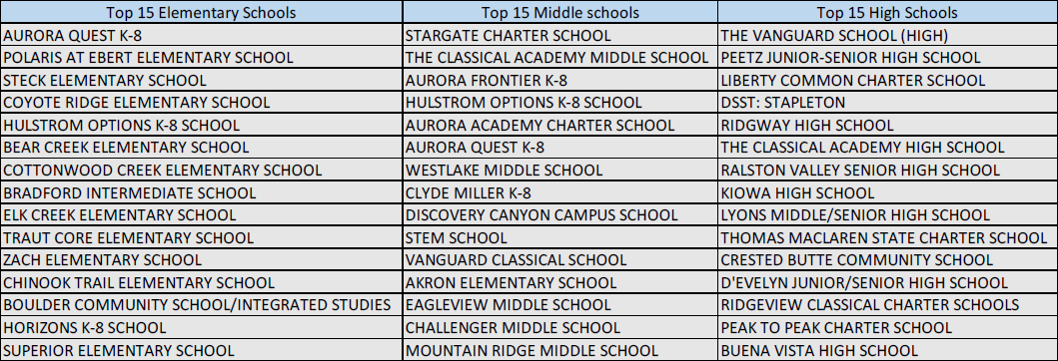

**Acknowledgements:**

We thank the Colorado state education system and Colorado School Grades organization for the data set. We thank the CNS center at SOIC providing extensive support and resources required for the project. Part of this work was supported by an NSF NCSE 1538763 award. Any opinions, findings, and conclusions or recommendations expressed in this material are those of the author(s) and do not necessarily reflect the views of the National Science Foundation.